# ROBOT DESIGN

The key factors taken into consideration while design the robot were:

* Dimension Constraints
  + The design had to be made in accordance with the dimensions provided in the problem statement. This mainly influenced the base geometry of the robot.
* Cleaning Efficiency
  + The robot had to be designed in such a way that optimal cleaning efficiency could be achieved.
* Equipment Onboard
  + The design had to take into account the electrical as well as the cleaning equipment needed to be installed into the robot. It had to make sure that there was not only enough space for the equipment to be installed but also be easily accessible and have enough space for them to perform optimally.
* Mobility
  + The design had to take care that the robot was mobile enough for it to cover the area quickly but at the same time not compromise on its cleaning abilities.

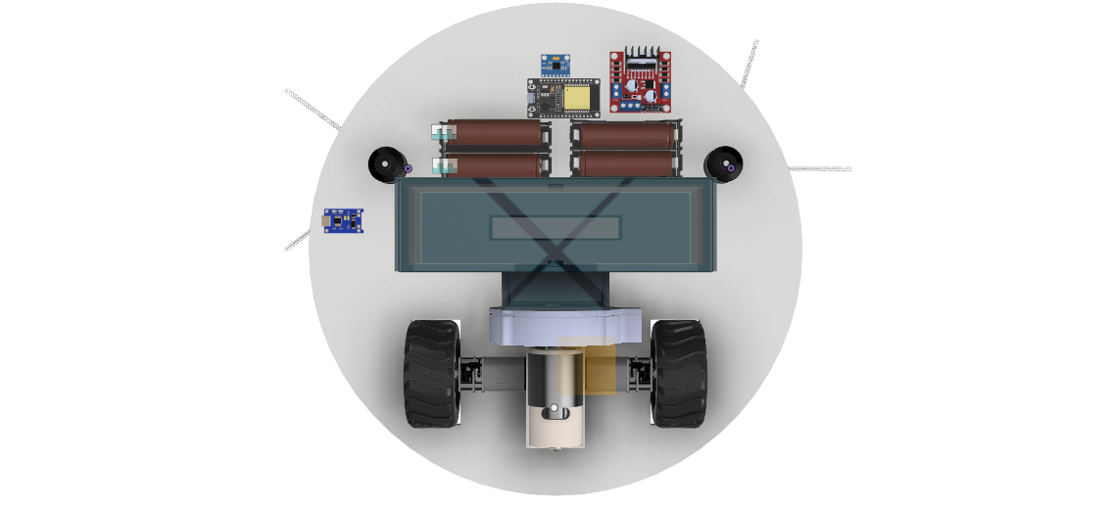

Taking into consideration the above factors, the robot was designed to be of a disk shape for better maneuvering with two rotating brushes on the sides for increasing cleaning area and efficiency. A three wheel system was carefully and systematically laid out to ensure low center of gravity and accurate control of the robot. The wheel placement was decided by triangulation method to provide more room at the front for a higher sweeping area for the brushes. The two motors provide the necessary mobility and the front caster provides the necessary support and stability for the movement.

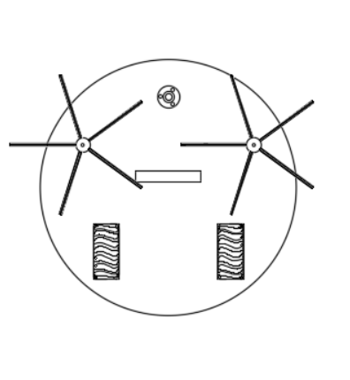

# Manufacturability

The material being used for the case and most of the robot is ABS because it is easily

manufactured, cheap and it can be **injection molded**. Acrylonitrile butadiene styrene, or

ABS, is a common thermoplastic used to make light, rigid, molded products such as

pipes, golf club heads. The styrene gives the plastic a shiny, impervious surface. The

butadiene, a rubbery substance, provides resilience even at low temperatures. ABS can be used between −25 °C and 60 °C.

ABS is relatively safe to handle as it cools down and hardens, making it one of the easiest plastics to handle, machine, paint, sand, glue, or otherwise manipulate.

The brushes are arranged in a circular pattern to provide complete all around coverage. The radius of the brush is taken to be **100mm** to provide efficient coverage. The brushes used are of **nylon** to provide necessary **strength** and **flexibility.**

# Serviceability

The top is attached to the side body by push joints and can be easily uncovered to give access to the internal parts. As a result all the internal parts can be directly accessed and be cleaned, repaired or replaced. The side body is connected to the base via screws at the bottom to give unhindered access to the internal components.

Since we expect the robot to function in a dirty environment, the mechanical parts used need regular maintenance for optimum performance and need to be replaced after a certain period of time.

| PART | CLEANING FREQUENCY | REPLACEMENT FREQUENCY |
| --- | --- | --- |
| BIN | AFTER EVERY USE | – |
| BRUSHES | AFTER EVERY 5 USES | AFTER 180 USES |
| FILTER | AFTER EVERY 5 USES | AFTER 50 USES |
| FRONT CASTER WHEEL | AFTER EVERY 10 USES | – |

# 

# Failure Cases

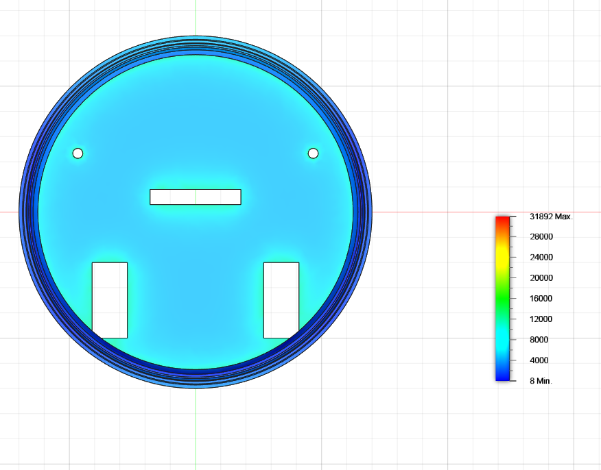The body has been designed with an appropriate quantity of ABS plastic to handle the weight of the components and the high torques developed due the motors. An approximate simulation for load design was done with an even distribution of 3 kgs over the base along with the outer case and the result gave a von Mises stress of 0.13 MPa. So the base can handle a lot larger loads as compared to the one currently applied. Even half the thickness of the base can be sufficient for the load currently applied.

The major cause of malfunction of mechanical elements can be seen in dust entering the parts. Dust entering the vacuum fan can lead to decrease in the vacuum power of the cleaner. Similar malfunctions can be caused by dirt entering the brush motors causing a reduction in the RPM of the brushes. Proper and timely maintenance of the filter can help in reducing these problems.

A good design practice is to provide a separate compartment for the electrical components, preventing them from being contaminated by the debris collected. So that they can operate optimally in an isolated environment, also providing proper ventilation to the batteries is necessary to stop them from overheating.

Redeposition can be a major problem leading to inefficient cleaning, placing a hinged cover on the mouth of the bin so that it closes once the vacuum process stops and no debris is allowed to escape back outside. Also making sure that the walls of the bin above the hole are at an angle to prevent the debris coming in at high speed to bounce right back out of the bin.